Deployment Guide

Reset Poor Media Data Protector

Version 1.0

January 27, 2022



## Document Information

|  |
| --- |
| Use Case / Content Request (UCMS) # 44269 & 53361 |
| Developer  CHINTALAPUDI, ANAND VARDHAN <a.chintalapudi@dxc.com> |
| Approved by  Gopalan, Suresh |
| Owning Capability  Backup |
|  |

## version history

|  |  |  |  |
| --- | --- | --- | --- |
| **Version** | **Version date** | **Updated by** | **Affected section and description of change** |
| 1.0 | 2022-01-27 | CHINTALAPUDI, ANAND VARDHAN <a.chintalapudi@dxc.com> | Initial Release |
|  |  |  |  |
|  |  |  |  |
|  |  |  |  |
|  |  |  |  |
|  |  |  |  |
|  |  |  |  |
|  |  |  |  |
|  |  |  |  |
|  |  |  |  |
|  |  |  |  |

## PREREQUISITES

* Script Hosting System should have powershell version 3.1 and above.
* Automation user should have necessary permission to access all the BKP Application directories without sudo access.

# 1 Deployment Procedure

## Backup Server

Logon to the Windows Backup Server or the Jump Server and copy the below folder to any directory**.**



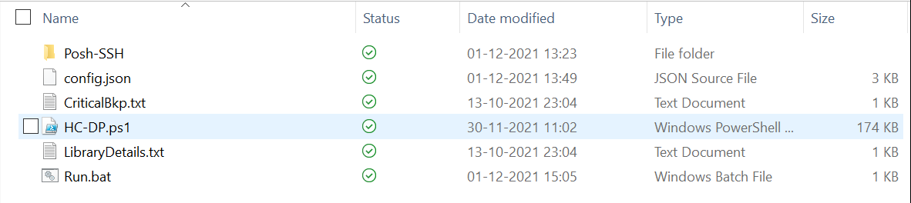

* Before Extracting go to the properties of Zip file and unblock the file if it is blocked.
* Provide the required fields in the **config file(config.json).**
* Mention the Pool Names in  **InputPoolFile.txt** and run the **run.bat** file.
* This will ask the user credentials to logon to Unix Backup server for remote connections and it does not require any credentials for running locally on windows Backup Server.
* This will create **cred.xml** file with given credentials which is encrypted.
* Schedule the **run.bat** file accordingly.
* If you have more than one backup server, create separate directory for that and perform the steps mentioned above.

**Config.json Parameters:**

**Info 1:** Change the parameters under this category accordingly.

* **Account :** Provide the Account name.
* **BackupServer:** Provide the BackupServer name of Windows or Unix Machine

(Incase of Unix use **ip address** in servername if servernme is not resolving, in this case use **“ip address;servername”** to see servername instead of ip address in generated report.)

* **ReportPath:** Provide the path of folder separated by **“\\”.**

Eg: C:\\ BURAuto\\HC

* **SmtpServer:** Provide SMTP details.
* **To:** Provide the To address, separate with **“;”** if there are multiple addresses.

Eg: “[example1@dxc.com;example2@dxc.com](mailto:example1@dxc.com;example2@dxc.com) “ or “ example@dxc.com”

* **CC:** Provide the CC, separate with **“;”** if there are multiple addresses and keep it blank if no available **“ ”.**

Eg: “[example1@dxc.com;example2@dxc.com](mailto:example1@dxc.com;example2@dxc.com) “ or “ example@dxc.com”

**Info 2:(ONLY UNIX)**

* Change the paths under this category in case of **UNIX** if paths used are different.

**InputPoolFile.txt Parameters:**

Provide the Pool that you want to monitor.

InputPoolFile.txt contain Pool names in below format

Pool1

Pool2

Script working Procedure :

* The command **“omnimm -list_pool -detail”** provides the list lof available pools in the backup server we are running the script.
* Now we check for the pools given in the **“InputPoolFile.txt”** with the above command output.
* We take only the pools given in input file which has **Poor and Fair Media.**
* For every pool from the above output we run the command **“omnimm -list_pool PoolName”,** which gives the available labels under that Pool.
* The command **“omnimm -reset_poor_medium Label”**  will be run to reset the labels which has status as **Poor and Fair**.
* The report will be sent to mail mentioned in config.json file.

Note :

* The default timezone in the report is **EST.**
* If credentials of unix machine changed, please delete the **cred.xml** and run the **run.bat** file to provide the new credentials.

Sample Report :

